

A Level Project

COMPUTER SCIENCE Component 3



June 18, 2018

Sam Macdonald

Mildenhall College Academy Sixth Form

Contents

Analysis - 1 -

What is the problem? - 1 -

Why is a Computational approach the most amenable? - 1 -

Stakeholders - 2 -

Research - 2 -

Features of the computational solution - 5 -

Limitations - 5 -

Requirements - 6 -

Success Criteria - 6 -

Design - 8 -

Top-Down Design - 8 -

Program Specifications - 8 -

Solution Design - 9 -

Objectives / modules - 9 -

software requrements - 10 -

# **Analysis**

## What is the problem?

After having an interview with my client and getting the requirements, the problem they have is relatively straight forward to solve. My client works for a company who deals with border control, surveying maritime routes for search and rescue as well as illegal activity. Currently, my client uses a notepad and pen to manually record the variables of the flight during each mission. This is not very efficient or useful because the data cannot be manipulated to produce reports or statistical modelling, for example. As the data is input manually, there is no validation so there can also be a lack of data consistency or integrity. As well as being time consuming, my client may have to search through the data manually, which is very inefficient. Due to human error, the client also makes mistakes and crosses out information, making it hard to read and understand what data there is when reviewing at a later date. This current manual input of data, from the notepad and then into a computer is laborious and repetitive which can be made redundant, therefore taking out the notepad stage along with the inherent issues associated with this method of recording.

## Why is a Computational approach the most amenable?

This problem needs a computational approach to solve it, rather than a manual/human approach, because the program would need to store a lot of information; if there are, for arguments sake, 100 different records in the database, it would be difficult to search for a particular attribute because a hand-written database doesn’t give you the privilege of using queries to search throughout the database. Therefore, it is much more efficient to store the data in an electronic database. Having a hand-written database can be prone to human error, because each day (a record) will have similar data and can be very repetitive, allowing the user to make mistakes; a computational approach to the problem will allow the user to edit and change data if they ever make a mistake.

The program also needs to import a Keyhole Markup Language (KML) and a computer is needed in order to do this – doing this manually would be virtually impossible. A KML is way of visualizing a map route geographically. Having a computational approach gives my client more scope, allowing them to do more with the raw data. Furthermore, if the user enters a note in the timeline for 10:00, and then decides to add another note at 09:00, the program can rearrange the table timeline so it is in chronological order. This would be difficult to amend on a manual record requiring re-written data and poor use of time and resources. In addition to this, the problem I will be trying to solve will be high client-side, because it will have a GUI to visualise the form, KML, print layout etc. in a clear, easy-to-read format.

A computational approach is suitable for this problem, because decomposition can allow me to break down the problem systematically, into its smaller components/modules, making it easier to code and understand each of the modules. Thinking about this problem with an abstraction approach would be useful, because it will allow me to take out unnecessary material that would not be effected in the program, just leaving the variables. The problem requires a lot of decisions made (e.g. if the user has entered text or if they have imported a KML) therefore taking this program with a logical approach would be beneficial.

## Stakeholders

### Those interested in this program would include individuals, and/or companies who have the need to log their flight missions. This could be the military, aerial imagery sectors or border control agencies such as Frontex. My client, who is also my end user, is familiar with flight missions and the key terminology which would be required in this program (e.g. ETD, ETA, MSN Time, Eng On, Estimated Time of Departure, Estimated Time of Arrival, Mission Time and Engine On respectively.

### My stakeholder(s) will have a major input on the program’s development giving me feedback at each stage and suggestions for improvement. They will also directly influence the specification points that the program must meet to be successful.

### In addition to this, I will need to produce a prototype of the program that is on course with the development timeline, to meet the client’s needs and may require adaptation during the process. Regular contact with and feedback from the client will ensure the project remains on track or allows for changes, which would need to be controlled to allow adjustments to scope, timeline or budget to give enhanced functionality to the client. Because my end user is my only stakeholder, I will not need to worry about disagreements between stakeholders regarding their requirements or outcomes.

## Research

**First interview**

I need to arrange an interview with the client, finding out specifically what the problem is and how I, the programmer, can make a product for them. Because I cannot currently meet the client in person, I have emailed them a questionnaire, providing questions to get enough information as possible. Here is a screenshot of the questionnaire document:

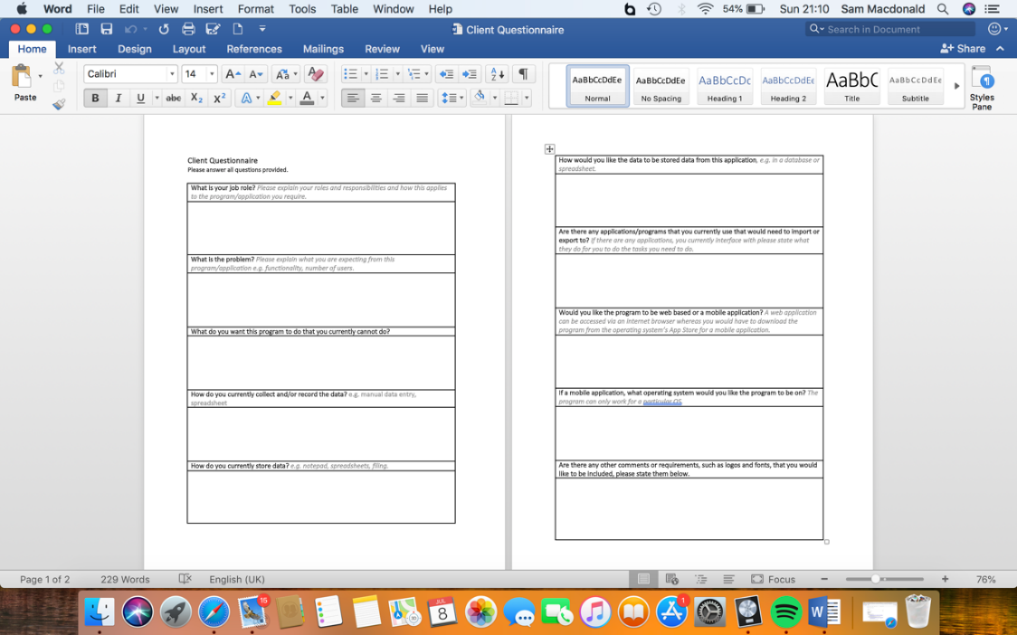

Here is a screenshot of the email I sent to the client, asking them to complete the questionnaire and to get back to be at their earliest convenience.

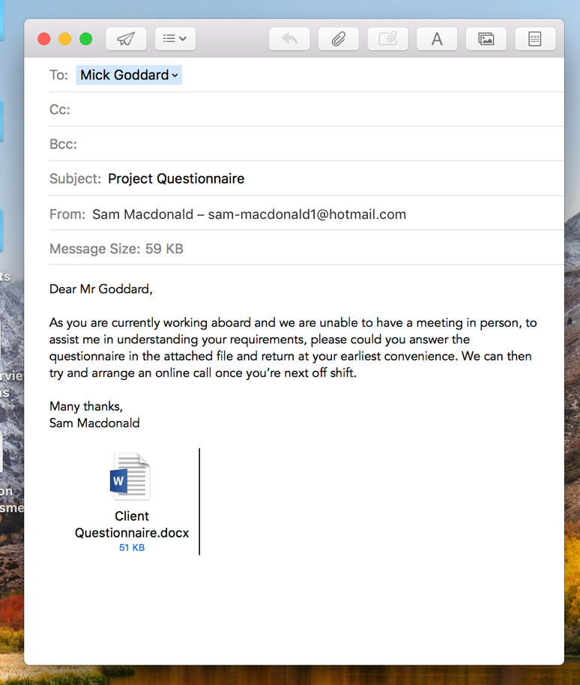

**Existing Products**

Adobe Acrobat is a family of application software, developed by Adobe, which allows the user to view, convert, edit, sign and print Portable Document Format (PDF). This application has some useful aspects for when the end users export a file as a PDF. As with all applications, there are some advantages and disadvantages. One advantage is that it is an Adobe product, meaning that it is legitimate software, providing conformity and reliability: Acrobat stores every detail (such as spacing, pictures and fonts) within the file itself, making it easier to share documents - if the provider has a font that the recipient has not got, the recipient doesn’t need to install the font. On the other hand, Adobe requires the user to pay for the full version of Acrobat: its £13.14 per month for the “Adobe Standard DC” package or £15.17 per month for the “Adobe Pro DC” package. However, Acrobat does offer a free version which has limited and restricted features.

Google Maps and OpenStreetMap are mapping software in which the user can view the world from the streets. However, this requires the internet, because it uses the uses GPS and the user’s location. An advantage of both applications is that it allows the user to import a KML (which is what the client wants out of my program.) However, some disadvantages of Google Maps and OpenStreetMap is the limited accuracy and the loss of privacy. Moreover, Google Earth is a similar application to both Google Maps and OpenStreetMap and is more beneficial for the client’s needs: the application can provide an up-to-date, detailed and accurate map of the world, providing support and resources for the client in what they currently do. When coding the program, I was going to import a KML separately and then the user imports a screenshot of the map to then place the KML over the top, but after researching the application, I found that not only can the application import a KML, but it can also be embedded into a webpage – being more efficient to code and giving the client a professional program.

Microsoft Excel is a spread-sheeting software, that my client can create tables as well as importing a KML. An advantage of using Excel is that is a generic, easy to use, application that my client can already use. However, using a table or database in excel is inefficient, inconsistent and unreliable (if there is the same attribute in multiple tables, and I update an attribute in one table, the other table wont update). On the other hand, with Excel, you can create graphs from the tables, so, for example, my client could draw graphs of the average mission time in a week. Microsoft Access is another application, similar to Excel, but deals with databases more, allowing search queries and to sort/filter records. phpMyAdmin is a software tool that handles with the administration of MySQL over the internet. A programmer that can use PHP and would like to connect their code to phpMyAdmin, giving them the facility to create, manipulate and store data in tables. However, the programmer would need to download and run XAMPP, an open source web server, to be able to connect to phpMyAdmin

Currently, my client uses notepad and pen to record the data for each of the flight missions. This may be cheap and easy to use, it is very inefficient to store because they use a manual, paper database. This means they would have to manually search through the database if they want to search for an attribute, being time consuming as well as inefficient.

**Bibliography**

* <http://smallbusiness.chron.com/advantages-disadvantages-using-acrobat-77144.html>
* <https://acrobat.adobe.com/uk/en/acrobat/pricing.html?mv=search&sdid=1FJDDN6S&s_kwcid=AL!3085!3!193496851174!b!!g!!acrobat&ef_id=WzXswwAABKLQJVza:20180629082541:s>
* <https://www.buzzfeed.com/nirdesh191/disadvantages-and-advantages-of-using-google-maps-2q8ao?utm_term=.sq2mDMPqP#.ra0JWbOlO>
* <https://sites.google.com/a/teacherportal.ca/exploring-earth/ge-advantages-disadvantages>
* <https://www.phpmyadmin.net/>

**Second Interview**

## Features of the computational solution

The client requires some sort of software that allows data input electronically, giving the option to update information. They have approached me to produce them a program which logs a flight mission in an easy-to-read table and field format. They want the data to be stored in a database, allowing them to access previously inputted data beforehand. The client would also like the program to import a KML which can be placed onto a mapping software. Once the client has inputted the data, they would like the option to see this data in a table format, and have the option to create a timeline of events which will take place for the duration of the mission. The client would like the option to have the facility to print the data inputted for a particular date, the KML on top of a geographical system and a timeline of events, as a PDF

## Limitations

Whilst I aim to provide exactly what my client wanted, there are several limitations affecting the development of the solution; one of which is that my client has a busy schedule working abroad of 4 weeks on and 2 weeks off. If I need to contact them for advice/questions or to arrange an interview, then I would have to wait until they are off shift remotely, or meet when they are back in the UK. This could potentially slow down the development of the solution.

For arguments sake, if the client requested a phone application, rather than a web application, I would need to get the application certified by the Apple and Android: it is $99 a year and $25 for a one-off payment, respectively. The solution must be for a specific operating system; if my client initially wanted their program on iOS and in the near future changed over to Android, then the program would not be available because the code would be complied differently due to the type of operating system.

In addition to this, if my client would like a web application, then an internet connection would be needed in order to connect to the database on phpMyAdmin.

My client only wants the solution to work for him, meaning that having a log-in section would seem pointless and not really benefit them because it is for one user. However, if in the near future my client has a team in which multiple users can log on simultaneously, then I would adapt the program to allow for this.

My client would like the solution to import a KML, and print off a map showing the KML flight path. This module will probably be the most complex part of the solution, but after researching into the problem, I can embed Google Earth into the program, which will allow me to import a KML.

## Requirements

The client would like a program that records the different variables related to a flight mission, which will calculate the flight duration, then saving the inputs into a database. My client can have the option to upload a KML which can then be placed over a geographical software such as Google Earth. Once setting the values in the database, my client would like view the records and have the ability to select one, displaying all the data in a table format. My client can have the option to upload a KML which can then be placed over a geographical software such as Google Maps or Google Earth. There will be an option to input and view data in a timeline for each date where the client can a time and the event that took place: for example, at 10:00, an event happens during the mission. Another table would be needed for this – having time and events as the column headings. However, if the user then adds a note at 09:00, then this will go before the 10:00 note so I need to create a sub-function that orders the timeline in chronological order. The client can have the option to print the table of data, KML, and timeline as a PDF, having the table of data and KML on one side, and the timeline on the other. My client also wants the DEA (Diamond Executive Aviation) logo printed on the PDF so I’ll need to somehow import that image, storing it permanently.

If my client decides to have a web based application, rather than a mobile application, then the language I will use is PHP and HTML, whereas if my client uses a mobile application then I can either use Java or Python, or use their database application – JBDC for Java and SQLite for Python respectively.

## Success Criteria

For my program to be successful, it must meet all the requirements above. To find out if all the requirements are met, I will produce a questionnaire to give to the client, after the development and testing stage of the project. Their response of the criteria will tell me if the program has met their needs and satisfaction and if any improvements/maintenance are needed, giving me an indication on how successful the program is. Some of the questions I will include in the questionnaire will be as follow:

Does the program…

* Open/load up with no faults?
* Allow the user to select different sections from the home screen?
* Allow the user to create a new mission?
* Allow the user to enter data into the text fields?
* Allow the user to submit the data?
* Allow the user to view all the dates and information?
* Allow the user to add a timeline?
* Allow the user to import a KML?
* Allow the user to export as a PDF?
* Print the document in the format/layout you intended?
* Meet your satisfaction?

Is the program…

* Accessible?
* Clear and easy to use?
* Clean and simplistic?
* Fast to load pages?
* Meeting your needs?
* Are there any improvements needed to be incorporated into the solution?

These criteria will be quantified with a scale of 0 to 10, where 0 is poor and 10 is excellent.

# **Design**

### In order to produce a working solution effectively, I must first think about the design stage of the problem. In this stage, I would need to produce flow charts, pseudo code and a prototype model for the client.

## Objectives / modules

**Objective 1 – Creating the home screen**

The home screen is the first page the end user sees, so I need to make this appealing, simplistic and easy to use. The home screen would need to have the application title at the top of the page, with two headings for the user to access the application; they will be “set mission data” and “view missions”.

**Objective 2 – Setting a missions data**

If the user clicks on “set mission data” they will be sent to a page where there will be a form for the user to enter the data for a particular mission. I will include validation by checking whether a text box has any data inputted into it. There will be a submit button where the user can submit their data to the database.

**Objective 3 – Viewing a list of missions**

When the user clicks on “view missions”, then they would be directed to page where all of the previously inputted data is stored. Each of the missions will be in date chronological order, having the date, mission number and call-sign as the header, which will allow the end user know what mission the header is referring to However, if there has been no data inputted, then a message will appear saying “no missions stored, please create a mission first.” There will also be a back button, directing the user back to the home screen.

**Objective 4 – Viewing a particular mission**

If the end user then decides to select a particular date by clicking on the header, then they would be directed to a new page where all of the stored data would be displayed in a table format. The date, mission number and call-sign would be at the top of the page, and all the other attributes underneath. At the top of the table, the user has the option to create a timeline of events, import a KML or export as a PDF. There will also be a back button, directing the user back to the list of mission’s page.

**Objective 5 – Creating a timeline of events**

This will be achieved by allowing the user to have the option to input the time of the event, as well as any notes. Once inputted, the user can submit the event which can be stored in a database. The end user can have unlimited events, each being stored in the database.

**Objective 6 – Importing a KML**

The user can import a KML, by clicking on “Import KML”, which will give them a pop-up menu of their documents. The user can select the file and click “Import”. This will then embed Google Maps into the program, and the KML on top of the map, allowing the user to view the route of the flight mission.

**Objective 7 – Exporting as a PDF**

To achieve this, there will be a “Export as PDF” button. If the user clicks on this button, the program will display a print menu, selecting the size of the paper, if it was going to be double-sided or not, and the printer it was sending the document to, much like pressing Control-P on a computer in Word Processing.

## Program Specifications

The program must:

1. Allow the user to create daily data
   * So the end user can keep a daily record of flight missions.
2. Store the daily data into a table in a database
   * Storing data keeps a record of flight missions, allowing the end user to come back to it at a later date.
3. Allow the end user to access and view previously created data, viewing all of the missions metadata
   * So the end user can import a KML or export as a PDF at a later data.
4. Allow the user to import a KML
   * So the end user can physically see the route of the mission.
5. Allow the user to create a timeline of events
   * This allows the end user to make notes and document any data during the mission.
6. Allow the user to export the document and print as a PDF
   * This allows the user to have a physical copy of a daily record.
7. Contain validation
   * This will check whether the user has entered anything valid, or anything at all into the textboxes
8. Be simple to use and navigate
   * Having a simplistic design to navigate through will be measured using the end users feedback.
9. Have a simplistic main menu to allow the user to switch between setting the data and viewing the data
   * To prevent unorganised, confusing aspects of the solution.

## Top-Down Design

### For this project, I have used a free, online, flow diagram application called *draw.io* to produce a top-down overview of my problem. Here is a screenshot of my initial design:

In the homepage module, there will be different sections allowing the user to access different parts of the program; this will be simplistic and easy to sue, meeting Program Specification 9. When adding data, there will be a form which the user can enter information. Validation will check whether the user has clicked the text box and if any fields have been entered, satisfying Program Specifications 1 and 2. Within the module that allows the user to view the data, Program Specification 3 is met because the program will allow the user to view the data in an ordered list. The module that imports a KML meets Program Specification 4 because

## Smaller computational solutuions

Broken the problem down systematically into a series of smaller problems suitable for computational solutions, explaining and justifying the process.

The problem can be broken down into smaller, individual modules, which can be tested separately. One module, within the solution, is allowing the user to enter and upload the data to a database. This can be broken down from the main solution because I can test it independently from the other modules.

## Solution Structure

Defined in detail the structure of the solution to be developed.

## Alogorithms

## Described the solution fully using appropriate and accurate algorithms justifying how these algorithms form a complete solution to the problem.

## Usability features

Described, justifying choices made, the usability features to be included in the solution.

## Within the homepage, there will be two options: added and viewing the data. The user can only select to add the data, the viewing section will be currently inactive because they have been no data added beforehand. Once the user has access to viewing the data, there will be a back button which takes them back to the home screen.

## Key variables, data structures and classes

## Identified and justified the key variables / data structures / classes (as appropriate to the proposed solution) justifying and explaining any necessary validation.

## the test data used in the interative development

Identified and justified the test data to be used during the iterative development of the solution.

## further data to be used in post development stage

Identified and justified any further data to be used in the post development phase.

# **Solution Design**

## software requrements

My client, who currently uses a Windows computer, would like a web application so I need to figure out how I would get PHP on my client’s computer, and after doing some research, I found that there are a number of ways to do so. My client would need to Microsoft Web Platform Installer (Web PI) which can allow them to install Internet Information Services (IIS). Web PI is a package management system that helps users install non-commercial development tools whereas IIS is a web software package used to host websites and other content on the internet. I’m making a solution for a single client – not a company – so my client probably does not have Web PI or IIS installed already (if I was making this for a company who has their own servers, most likely they would have already installed Web PI and IIS and therefore they could integrate my solution into their working environment.)

Alternatively, I could install PHP by using Web PI. Coding in PHP will allow me to use a database to store information on phpMyAdmin. I can also install XAMPP which will allow me to test the solution before I release it to the client. However, with XAMPP, I would need to open up the application, run Apache and MySQL (in that order) every time I would want to access the solution via the browser and phpMyAdmin, and when I would want to shut down the computer, I would need to stop Apache and MySQL.

Moreover, my client can download and install PHP and WinCache. WinCache stands for Windows Cache Extension for PHP is a PHP accelerator which makes PHP applications run faster on Windows and Windows Server. The extension consists of PHP opcode cache, user data cache, session cache, file system cache and relative path cache. However, this may be more of a simplistic way of doing this, I would still need to install IIS so either way of doing this wouldn’t differ from each other.

**Bibliography**

* <https://docs.microsoft.com/en-us/iis/application-frameworks/scenario-build-a-php-website-on-iis/configuring-step-1-install-iis-and-php>
* <https://searchwindowsserver.techtarget.com/definition/IIS>
* <https://editrocket.com/articles/php_windows.html>